cloud computing

Cloud computing--- without installing any software into local machines by using the internet through the URL, accessing resources and developing the application

Cloud computing will provide

SAAS software as a service

We can use but we cannot modify it

PAAS platform as a service

IAAS infrastructure as a service

SAAS will provide

Sales

Service

Marketing

CRM -Customer Relationship management

When you’re joining a company

The company provides you with the org (Organisation)needed to develop your code (dev)

Then it should move to the SIT (System integrated testing)

Then it should move to the UAT (User acceptance testing)

Then finally it will be moved to production.

Click Setup and search for creating custom object

Label name--user

Custom Object name---- Salesforce

API name ---Salesforce

Object name always word or word including _.

If labels contain special characters or space, then in object names it will be replaced with underscore _.

If we have special characters and space at the start or ending it won’t be considered.

When you are creating the object by default one column(filed) is created automatically.

API name is also automatically created which will be given by user (Username) by default.

It is like a unique identity

C means custom

API--Application Programming Interface

When you are creating objects by default 4 fields are created standard by salesforce.

if you name your custom object with spaces in the **Label**, like:

* **Label Name**: Hospital Name

Salesforce automatically generates internal names like this:

| **Type** | **Value** | **Notes** |
| --- | --- | --- |
| **Label Name** | Hospital Name | Friendly name shown in UI. |
| **Plural Label** | Hospital Names | For tabs/list views. |
| **Object Name** | Hospital_Name | Internal API-style name with underscore. |
| **API Name** | Hospital_Name__c | Used in code (must end in __c for custom objects). |

Now the object is ready we need to create tab

Click Setup and search for creating custom tabs

Storage space is ready need a tab to enter the details from the end user.

The plural label name in custom object comes as a tab name

When you are changing the plural name the tab name is automatically changing

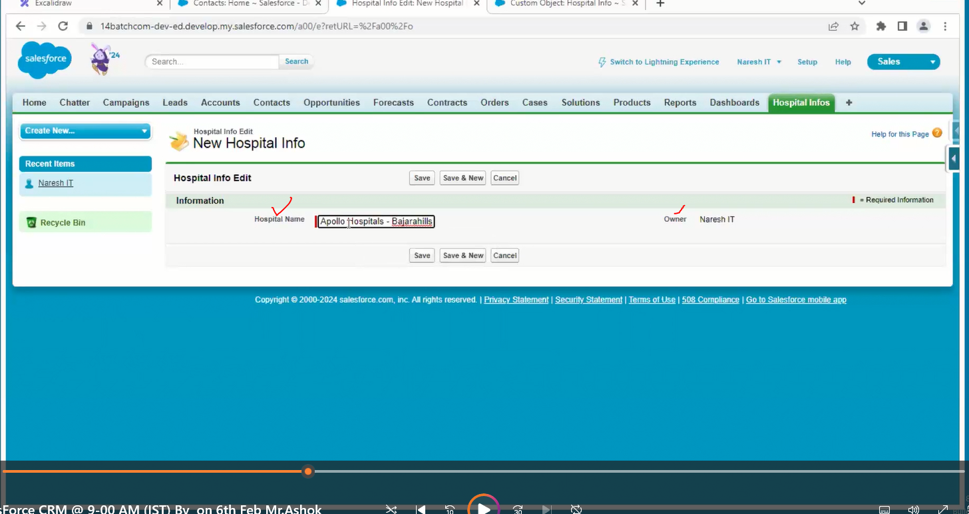

In the above we have 2 fields, one is hospital name, and owner is automatically filled by the system

For every record owner must be there.

Pick list

Number

Currency

Text

| **Field Type** | **Description** | **Analog in Programming** |
| --- | --- | --- |
| **Text** | Stores alphanumeric strings | String |
| **Number** | Stores whole or decimal numbers | int, float, double |
| **Currency** | Stores numeric values with currency format | float with formatting |
| **Picklist** | User selects from a dropdown list of options | enum or String[] |
| **Checkbox** | Boolean true/false value | boolean |
| **Date** | Stores only the date | Date |
| **Date/Time** | Stores date and time | DateTime, timestamp |
| **Text Area** | Multi-line text | String (multi-line) |
| **Lookup** | Links to another record | Reference or foreign key |
| **Auto Number** | Auto-generated number (like an ID) | Auto-incrementing int |
| **Formula** | Automatically calculated field based on logic or math | Function, Computed Field |

Ok now we have hospital information, doctor, patient & bed tabs

Please add all those tabs in one app, so create a new custom app

Click Setup and search for creating Apps

To add the icon to the app we need a document folder to store an image

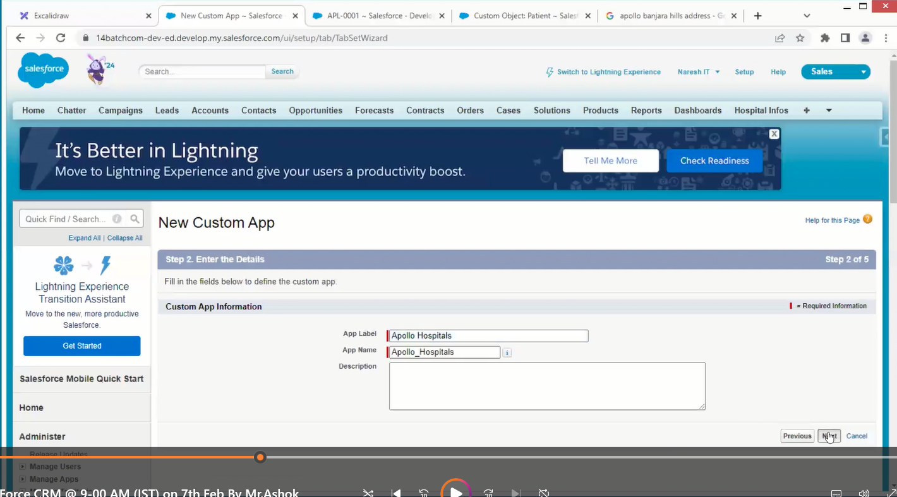

Every App have multiple Tabs

Every Tab has one object

Objects have multiple fields.

If data is increased the performance of the app decreases

In general, we will compress the data to zip file of lesser mb

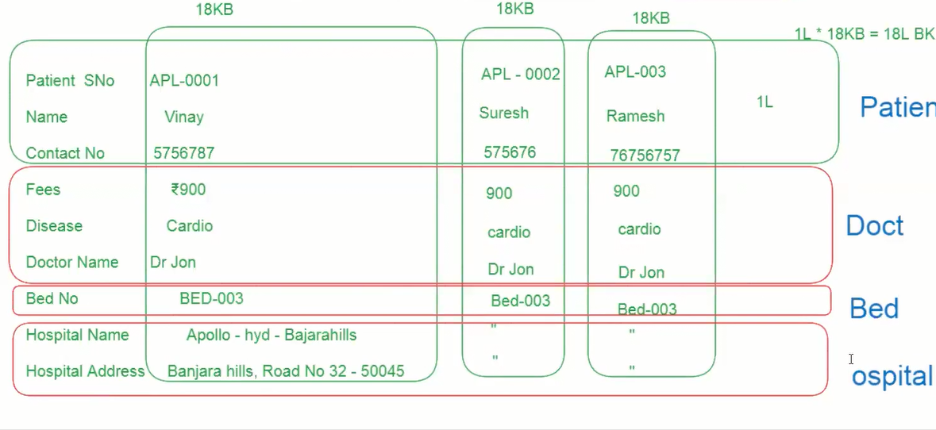

Data redundancy means duplicate data

The connection between the 2 objects is called a relationship

to reduce data redundancy.

Relationship into 2

1. Optional Relationship
2. Required / mandatory Relationship

Option relationship is nothing, but the object may require or not for relationship.

Required or mandatory means this object is 100 percent required for relationship.

1. Optional Relationship
2. Lookup relationships
3. Required / mandatory relationships
4. Master detail relationship

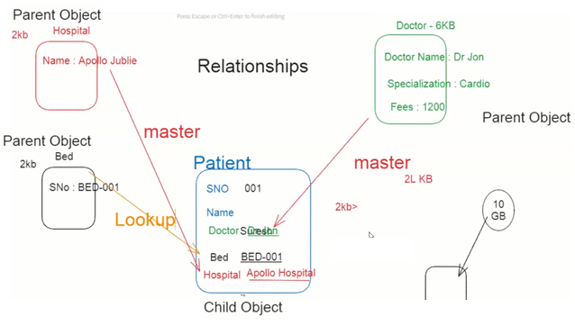

To create a relationship between objects, go to the child object and go to the new field /relationship



Case 1

Remove all the records of child-record and create (not recommended)

Case 2

Create LoopUp and update all relationship fields then convert it to master

In this case if a patient object is having 1lakhs record to update this it will take a lot of time for this we have some tools which are not created by salesforce

Data loader

Import wizard

Work bench

Inspector

Per object we can create only 2 master relationships and 40 lookup relationships

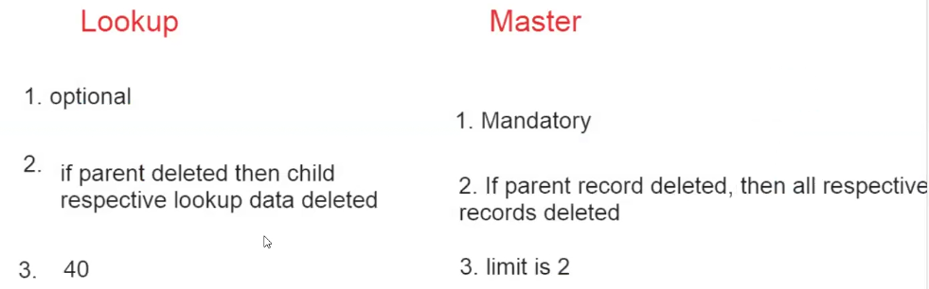

Sales force is going to provide editor to return some logic

After writing the logic in the editor when we submit it will go to complier to going validate our logic and then it moves to runtime engine giving the out put

Age is formulae we need to create formulae filed first

Formula fields

go to the object and go to the new field /relationship

Display purpose labels

Logic purpose API names



